
Integrated Municipal Information System (IMIS)
Innovative Solution Pvt. Ltd (ISPL)
Sludge Collections Mobile App
User Manual
Empowering Development through Data-driven Innovation and Information Technology Solutions

Sludge Collections Mobile App User Manual
Base IMIS 2022-2026 by ISPL & GWSC-AIT is licensed under CC BY-NC-SA 4.0 | Customized for DNCC
Version 1.0.1

Table of Contents
Chapter 1 Introduction 1
1.1 Purpose 1
1.2 Target Audience 1
Chapter 2 App Installation 2
2.1 Installation Procedure 2
Chapter 3 Accessing the IMIS 4
3.1 Opening the app/ Login 4
Chapter 4 Dashboard 7
4.1 Navigate to Dashboard 7
Chapter 5 Collecting Sludge Collection Information 1
5.1 Navigate to Sludge Collection 1
5.2 Tools 2
5.2.2 Sludge Collection Data 3
Chapter 6 MISCELLANEOUS (PERMISSIONS) 6

- Introduction
  - Purpose
This document is designed to guide desludging vehicle operators on how to use the Sludge Details Collection Mobile App. After completing an emptying service, the operator must transport the collected sludge to the designated Fecal Sludge Treatment Plant (FSTP) for safe disposal. At the time of disposal, the operator is required to fill out the Sludge Disposal Form within the mobile application. This process ensures that disposal activities are accurately recorded and linked to the corresponding emptying application. The app allows for the collection of information pertaining to the sludge emptied during the service, ensuring that data is updated in real-time. Users of the fecal sludge treatment plant can utilize the app to record details such as the start and end times of emptying, the number of trips made, the total cost for emptying, and the payment receipt number. The help desk, service provider admin, and treatment plant admin can view these fecal sludge collection details in real-time, provided they have access to the sludge collection module. The user manual outlines a step-by-step procedure for all the features implemented within the app. It is important to note that information related to the actual emptying and sludge collection operations can also be entered into the system via the web interface. The primary purpose of this application is to assist users in filling out the details of sludge collection and in viewing the applications received. It offers an easy-to-use interface that connects the emptying operator with the IMIS web application.
  - Target Audience
Targeted users of this manual are Desludging Vehicle Operators of the Municipality or Outsourced Agency. This manual guides the performance of details related to actual emptying operations.

- App Installation
An APK file will be made available in a common access location or shared via a link that can be downloaded and installed on your device.
- Installation Procedure
- Download the APK file on your device and go to the ‘Downloads’ folder in the ‘File Manager’.
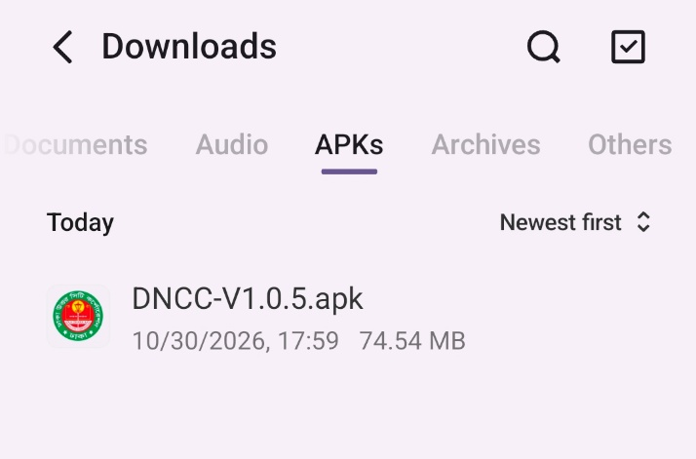
                - . APK file
- Locate the corresponding .apk file and tap on it. The installation process will begin.
- Tap on ‘SETTINGS’ and allow access, if the system asks permission to install the app from an unknown source.
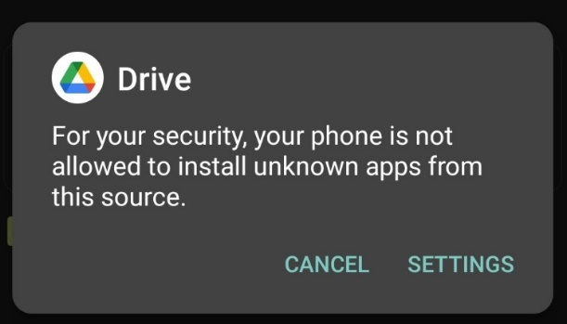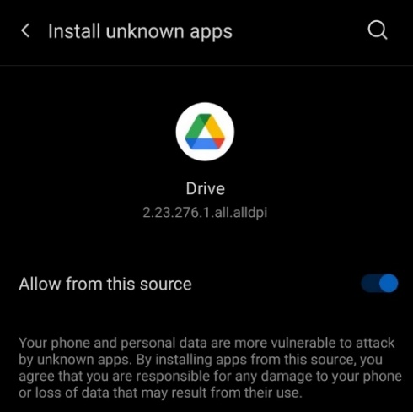
                - Access Permission
- Tap on ‘INSTALL’. An ‘Installing…’ progress bar will be displayed.
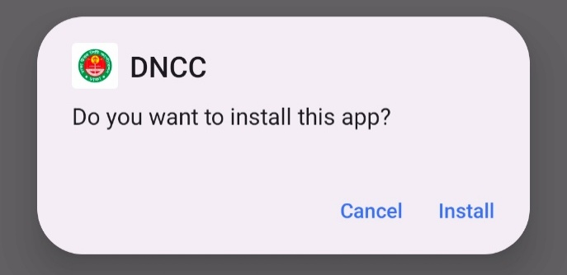
                - Installation process
- Tap on ‘Open’ after the installation process is completed.
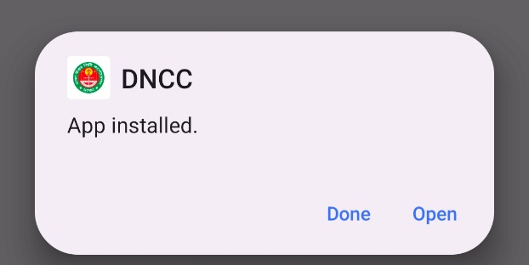
                - opening app
Overview:
- The installed app can also be accessed from the App drawer or Launcher.

- Accessing the IMIS
- Opening the app/ Login
- Open the IMIS mobile application. The Login screen will be displayed.
- Enter the email address and password provided by the Municipality Administrator.
- To keep the user signed in, select the Remember me checkbox, if required.
- Tap 'Log In' to access the application.
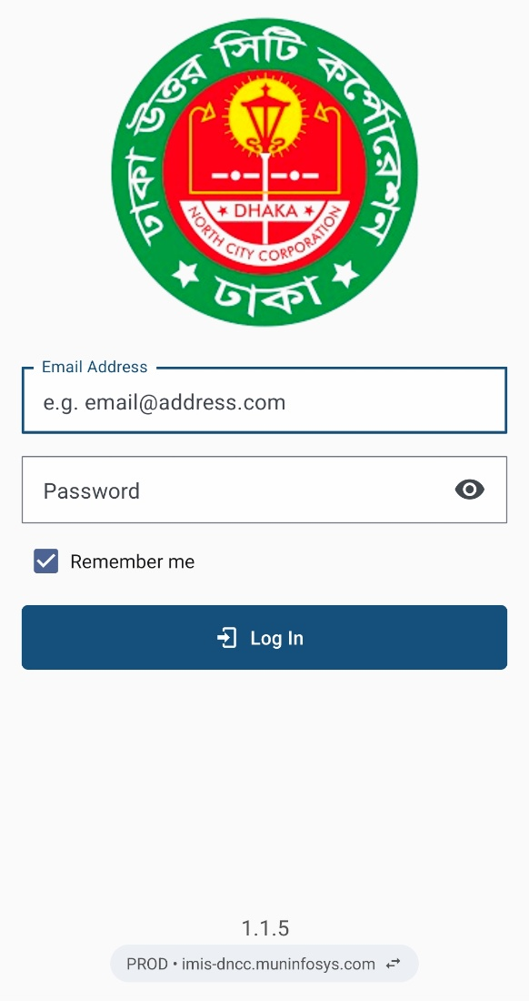
                - Login
Switching Between Servers
- The application allows users to switch between the Production (PROD) and Staging (STAGING) servers.
- The currently selected server and its URL are displayed at the bottom of the Login screen, below the application version number.
- Tap the displayed server URL to open the 'Switch server' confirmation dialog.
- Tap 'SWITCH' to change to the other server, or tap 'CANCEL' to remain on the current server.
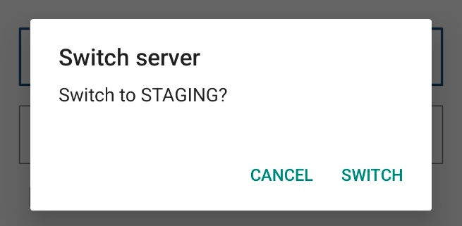
                - Switch Server Confirmation
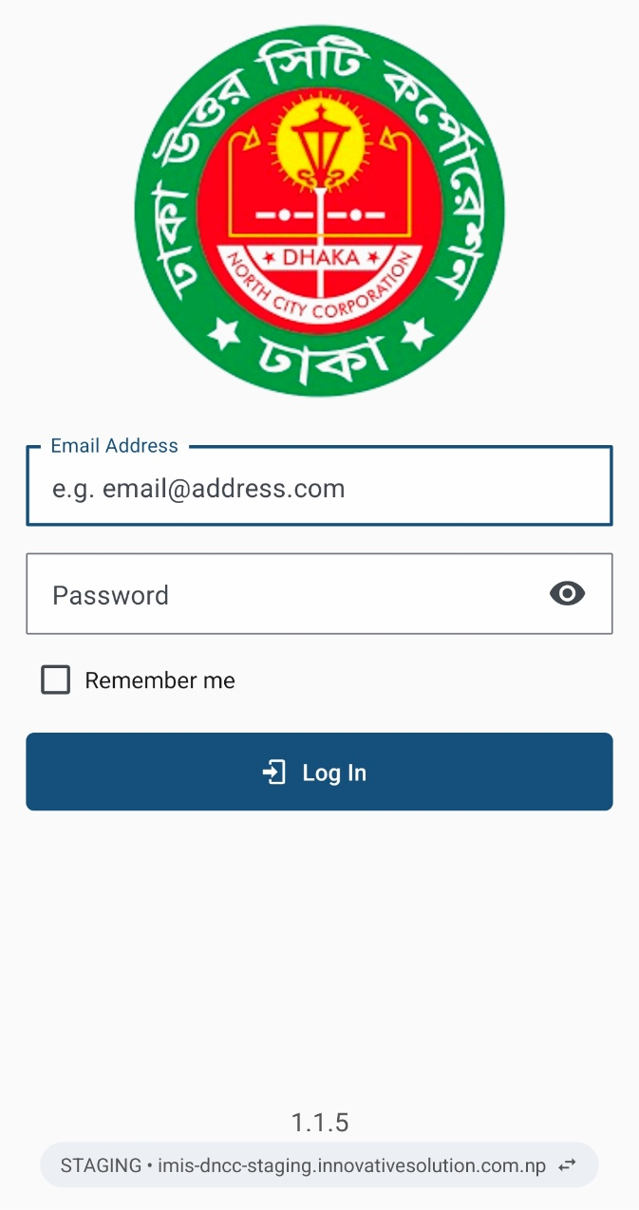
- After switching, the selected server name and URL will be updated at the bottom of the Login screen.
- Verify that the correct server is selected before entering the login credentials.

Overview:
- This login credential is created and provided by the Municipality IT Admin to the user role treatment plant admin user.
- The application retains the login information until the user's session becomes inactive and expires.
- It is to be noted that GPS needs to be turned on while using the mobile application. When the user is using the app for the first time. The user must provide the location permission to the app.
- Once a successful login, the user is redirected to the Dashboard screen.

- Dashboard
  - Navigate to Dashboard
- After successful login, a dashboard page is displayed.
- The user must select the ‘Sludge Collection’ card to enter details related to the collected sludge.
- Tap the three dots at the top right corner to get the log-out option.
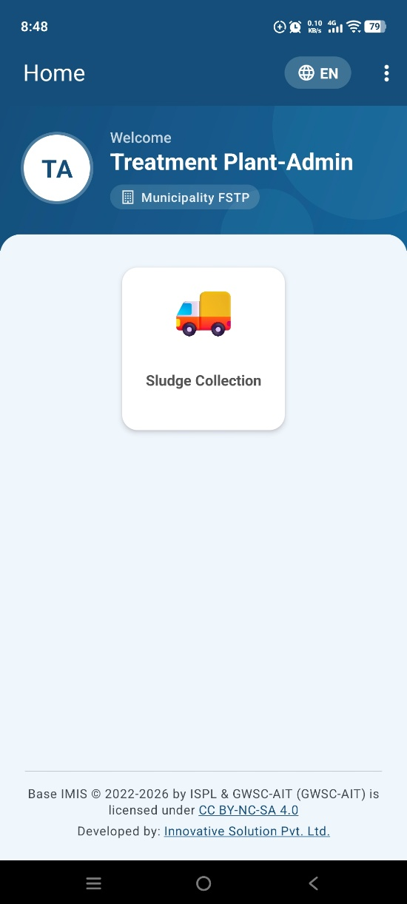
                - Dashboard
Overview
- Once the user is successfully logged in, the user is redirected to the Dashboard screen.

- Collecting Sludge Collection Information
- Navigate to Sludge Collection
- For collecting the sludge collection details of the application, tap on the ‘Sludge Collection’ on the dashboard.
- When tapped, the user will be redirected to a list of sludge collection applications that have completed an emptying service.

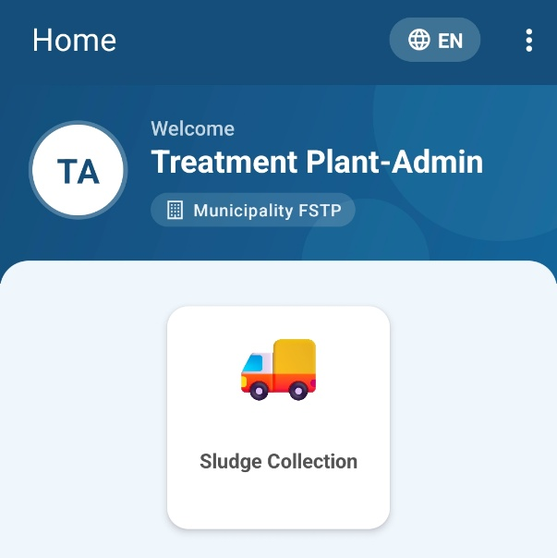
                - Sludge Collection
Overview:
- To initiate the sludge collection process, the user must first access the Sludge Collection List page.
- After being directed to the sludge collection list page, users can view a list of sludge collection applications to complete details related to the actual sludge collection operation.
- Tools
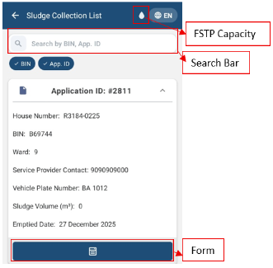
                - Sludge Collection List
- Search Bar: To search, first select one or all buttons: BIN, Name, and App. ID. Enter the BIN, Name, or App.ID.
- BIN: Select the button to enter the BIN in the search bar.
- App.ID: Select the button to enter the Application ID in the search bar.
- Form: Tapping on the form icon permits the user to fill out the form required for emptying the sludge collection service.
- FSTP Capacity: When the user clicks the drop icon, a pop-up will appear showing the FSTP Capacity details (location and daily sludge treatment capacity).
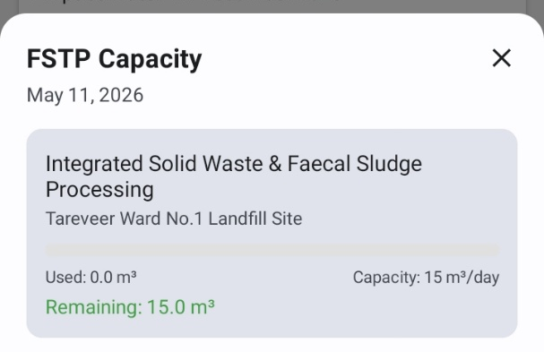
    - Sludge Collection Data
- Tapping on ‘Form’ redirects to the sludge collection form.
- Fill out the form on-site with the required details, and the user must press the ‘SUBMIT’ button to upload the details to IMIS.

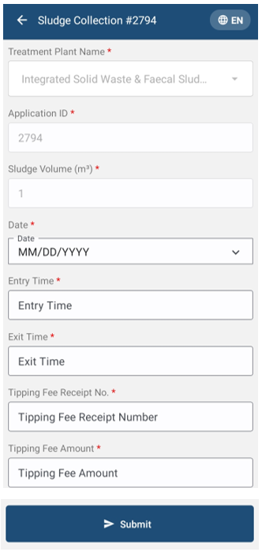

                - Sludge Collection Form
Overview:
The Sludge collection details page consists of different form fields, which are mentioned below:
- Treatment Plant Name: Displays the treatment plant name.
- Application ID: Displays the application ID.
- Sludge Volume (m³): Displays the sludge volume.
- Date: The date when the collected sludge was emptied.
- Entry Time: Enter the time when the sludge vehicle entered the treatment plant for emptying collected sludge.
- Exit Time: Enter the time when the sludge vehicle exited the treatment plant after emptying the collected sludge.
- Tipping Fee Receipt No: Enter the receipt number for the sludge collection.
- Tipping Fee Amount: Enter the tipping fee amount for the sludge collection.
Note:
- The Treatment Plant Name, Application ID, and Sludge Volume fields are disabled, and the value once entered during the emptying so it doesn’t need to be entered again at the sludge collection form.
- All fields marked with an asterisk (*) are mandatory and must be completed to submit the form. If any necessary fields are left empty, the application will not permit the user to continue. Incomplete fields will be highlighted in red to show which ones need to be filled in.
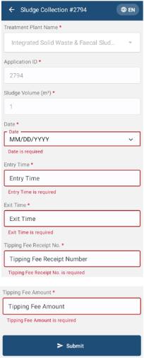
                - Sludge Collection Red Highlight

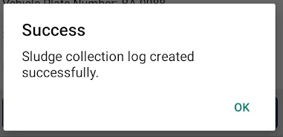
                - Success Message

- MISCELLANEOUS (PERMISSIONS)
- When the user first uses the application, they must provide the Location Permission to the app.
- Allow IMIS Base to access this device's location requested by the app by clicking “WHILE USING THE APP”.
- The user is also prompted to turn on location services at all times while using the mobile application.
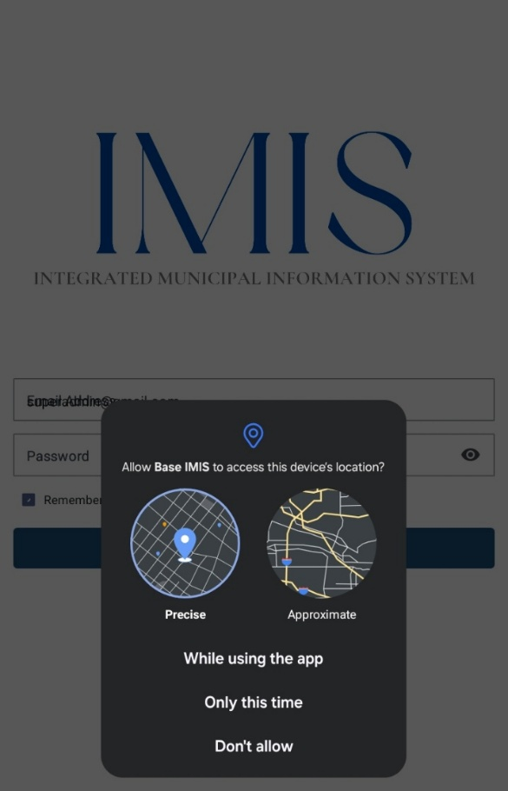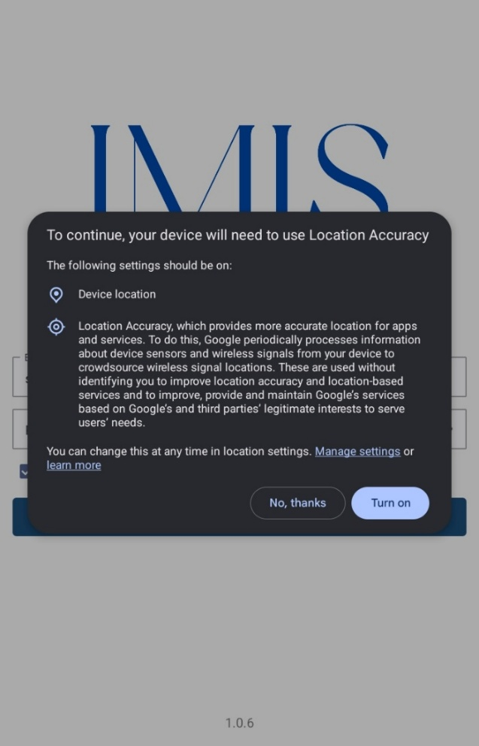
                - Location permission

